**2. Host a FTP and SFTP server and try PUT and GET operations.**

**2.a FTP:**

Steps:

* Install the package using the command **sudo apt install vsftpd -y**
* Add the new ftpuser and set up the password
* Edit the **vsftpd config file** and grant permissions for **write_enable=YES**
* Restart the FTP service
* Login to the FTP server using username and password.
* Use put command and upload the file.
* Use get command to download the file.
* Check the updation

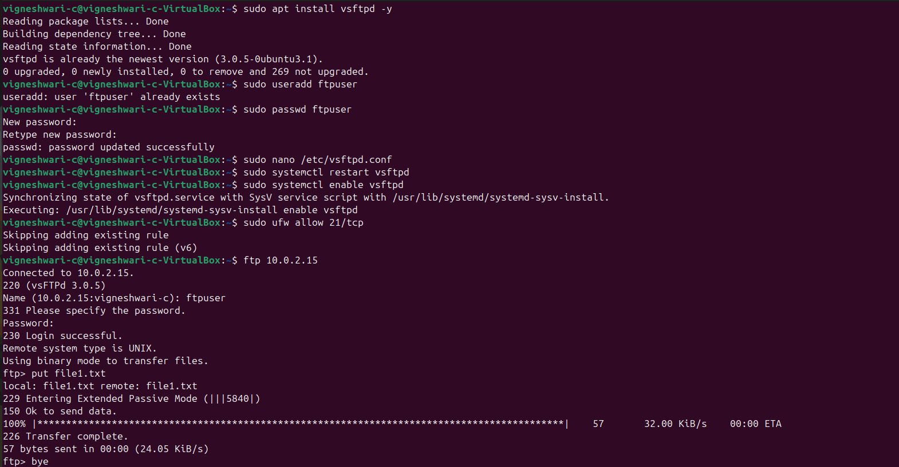

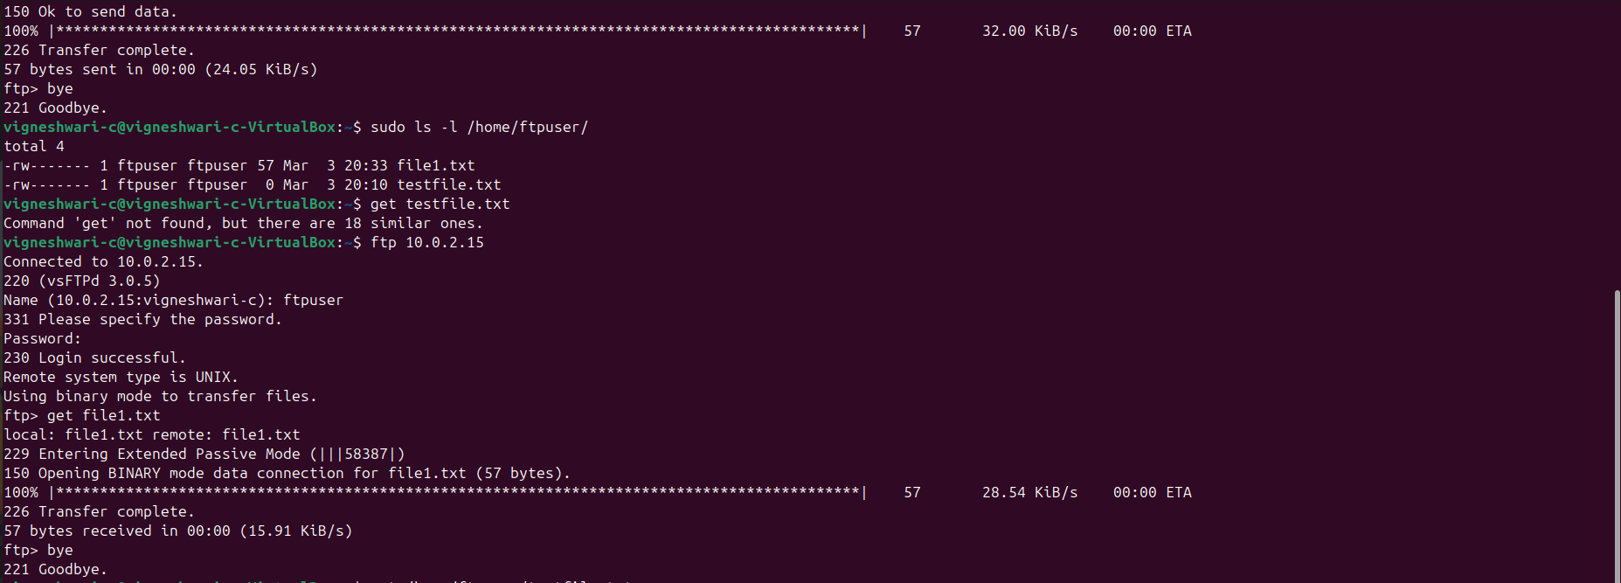

**2.b SFTP:**

Steps:

* Add the new sftpuser and set up the password
* Login to the FTP server using username and password.
* Use put command and upload the file.
* Use get command to download the file.

